UBND THÀNH PHỐ HỒ CHÍ MINH | CỘNG HÒA XÃ HỘI CHỦ NGHĨA VIỆT NAM
TRƯỜNG CAO ĐẲNG LÝ TỰ TRỌNG | Độc lập - Tự do - Hạnh phúc
THÀNH PHỐ HỒ CHÍ MINH
ĐỀ THI KẾT THÚC HỌC PHẦN LÝ THUYẾT
HỌC KỲ: I NĂM HỌC: 2017 – 2018

Bậc đào tạo: TRUNG CẤP Học phần: NGHE 1
Lớp: 17T4- ________ Ngày thi: ___ / ___ / 2017
Thời gian thi: 60 phút (không kể thời gian phát đề)

HỌ VÀ TÊN SV |  | Chữ ký Giám thị I | Chữ ký Giám thị II | Số mật mã
LỚP | SỐ KÝ DANH | Chữ ký Giám thị I | Chữ ký Giám thị II | Số mật mã
--------------------------------------------------------------------------------------------------------------------------
Chữ ký Giám khảo I | Chữ ký Giám khảo II | ĐIỂM BÀI THI |  | Số mật mã
 |  | (bằng số) | (bằng chữ)
1. Hướng dẫn làm bài
Đề số 002

Thí sinh không được sử dụng tài liệu khi làm bài.
Sinh viên làm bài ngay trên đề thi.
Bài thi này gồm 40 câu, mỗi câu 0.25 điểm.

2. Nội dung đề thi

Task 1: Listen to the story of the stonecutter. What is the main idea of each part of the story?
Number the statements from 1 to 4. Listen three times. (1p)
_____The stonecutter was too busy, and he was tired. He asked the genie to make him a rich man.
_____The stone cutter saw a man building a stone house. He understood that he didn’t need money and power to be happy.
_____The stonecutter lived with his wife in a small house. They were poor but happy.
_____The stonecutter found a genie in a magic lamp. He asked the genie to make him a prince.

-------------------------------------------------------------------------------------------------------------------------------------------------- Task 2: You will hear about the inventions.
Circle the reasons for them. Listen two times. (1.5ps)

- a. It was a children’s game. 4. a. There were no more cups.
b. It was a fortune-telling game. b. People wanted to eat while they walked.
2. a. They were a joke. 5. a. People wanted to take drinks home.
b. A custom wanted fast food. b. A rich man didn’t want to get sick.
3. a. It was made for tall buildings. 6. a. The inventor wanted to walk faster.
b. It was made for a king. b. The inventor wanted to help his father.

Task 3: Which statement about each telephone call is true? (Tac,u19,2)
Listen and circle the correct answer. (1.5ps)

- a. Joe is busy. 4. a. It’s a wrong number.
b.It’s a wrong number. b. Sylvia is out.
2. a. Sandy is not free. 5. a. Mrs. Brown can’t come to the phone.
b. Sandy is not in. b. Mrs. Brown is home.
3. a. It’s a wrong number. 6. a. Tony can’t come to the phone.
b. Brian is not home. b. Tony is in.
Task 4: Listen to people talking about cities. Circle what each person say about each place.
Listen three times. (2ps) (Tac, u23,task 3.2,p.91)
- a. There aren’t many interesting places to visit. 5. a. It’s pretty small and quiet.
b. There is a lot to do. b. It’s crowded and noisy.
- a. People are noisy in the street. 6. a. It’s not a pretty city.
b. It’s nice and quiet. b. The scenery is beautiful.

- a. The air isn’t clean. 7. a. It’s good for families.
b. The streets are not crowded. b. It’s dangerous.

- a. Everything is cheap. 8. a. It’s a small city.
b. Everything is expensive. b. It has great nightlife.

---------------------------------------------------------------------------------------------------------------------------------------
Task 5: These people are asking about the weather. What will they wear or take with them?
Listen and check the correct picture. Listen three times. (1.5p) (act, u17,task 3)

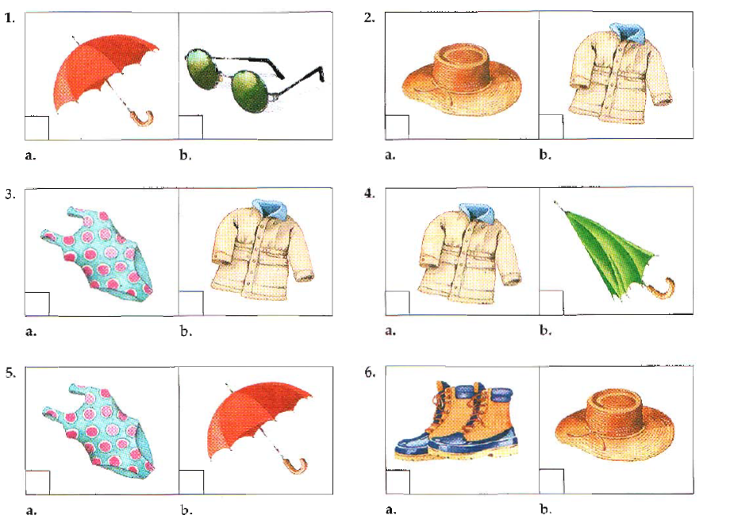

----------------------------------------------------------------------------------------------------------------------------------------
Task 6: Listen. People are talking about India.
Listen and fill in the blanks. (2.5ps)
India is the sixth largest (1) _______________ in the world. It is (2) _______________ in South Asia. India is (3) _______________ to many people from different (4) _______________, and they speak many languages. In fact, India has (5) _______________different national languages in addition to the official language, Hindi. English is also used for official purposes.
India is famous for its (6) _______________, especially its (7) _______________ dishes. Curry dishes with chicken, lamb or vegetables are very (8) _______________. Beef is not served often because many Indians don’t eat beef for religious reasons. India is also known for tropical fruits. There is even a (9) _______________ fruit – the mango. Indians drink many fruit juices, and Indian tea is very famous all over the (10) _______________.

______Hết_______
GHI CHÚ: CÁN BỘ COI THI KHÔNG ĐƯỢC GIẢI THÍCH GÌ THÊM.

TRƯỞNG KHOA TRƯỞNG BỘ MÔN GIẢNG VIÊN RA ĐỀ

Trần Kim Thu Liễu Nguyễn Thị Bảo Trân

1. country 2. Located 3.home 4. Cultures 5. 22/ twenty-two 6. Food 7. Spicy 8. Popular 9. National 10. World

